AI Forecasting ekran je zapravo jedan od najvažnijih ekrana za utility operatore jer objedinjuje:
- Load Prediction
- Blackout Prediction
- Transformer Lifetime Prediction
- Grid Stability Forecast
- Weather Impact Forecast
- AI Recommendations

AI Forecasting Layout
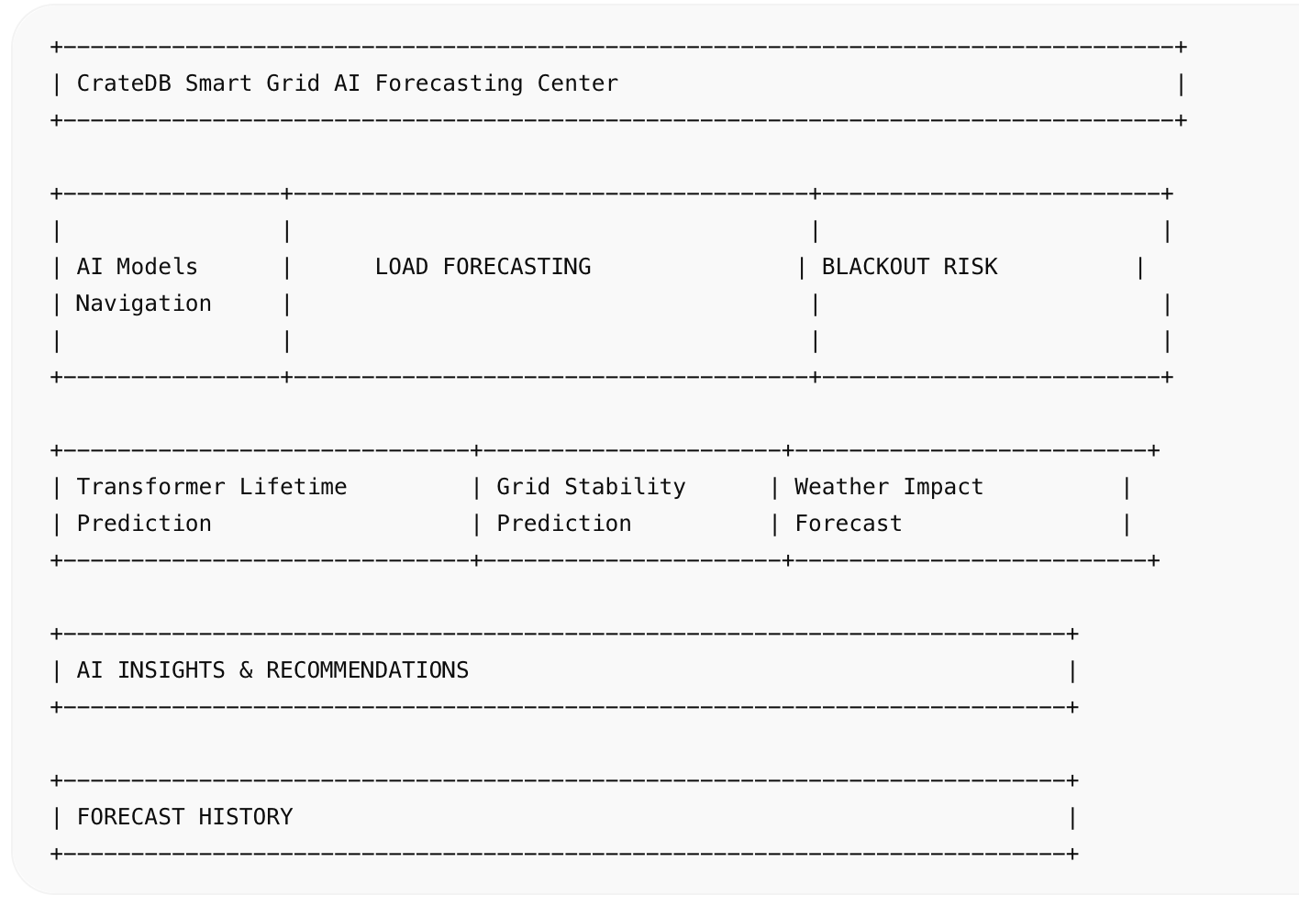

src/pages/AIForecasting.vue
<template>  <q-page class="bg-dark text-white q-pa-md">  <div class="row items-center justify-between q-mb-md">  <div>  <div class="text-h4 text-primary">  AI Forecasting Center  </div>  <div class="text-grey-5">  Smart Grid Predictive Intelligence  </div>  </div>  <div class="row q-gutter-md">  <q-chip color="green">  Grid Stable  </q-chip>  <q-chip color="orange">  Forecast Confidence 94%  </q-chip>  </div>  </div>  <div class="row q-col-gutter-md">  <!-- LOAD FORECAST -->  <div class="col-8">  <q-card dark bordered class="bg-grey-10">  <q-card-section>  <div class="text-h6">  Load Forecast (Next 24h)  </div>  </q-card-section>  <q-card-section>  <div class="forecast-chart"></div>  </q-card-section>  </q-card>  </div>  <!-- BLACKOUT -->  <div class="col-4">  <q-card dark bordered class="bg-grey-10">  <q-card-section>  <div class="text-h6">  Blackout Prediction  </div>  </q-card-section>  <q-card-section class="text-center">  <q-circular-progress  show-value  :value="12"  size="180px"  color="red"  >  12%  </q-circular-progress>  <div class="q-mt-md text-red">  LOW RISK  </div>  </q-card-section>  </q-card>  </div>  </div>  <!-- KPI -->  <div class="row q-col-gutter-md q-mt-md">  <div  class="col-4"  v-for="item in predictions"  :key="item.title"  >  <q-card dark bordered class="bg-grey-10">  <q-card-section>  <div class="text-subtitle2 text-grey-5">  {{ item.title }}  </div>  <div class="text-h4 text-primary q-mt-sm">  {{ item.value }}  </div>  </q-card-section>  </q-card>  </div>  </div>  <!-- AI INSIGHTS -->  <div class="row q-mt-md">  <div class="col-12">  <q-card dark bordered class="bg-grey-10">  <q-card-section>  <div class="text-h6">  AI Recommendations  </div>  </q-card-section>  <q-list separator>  <q-item  v-for="recommendation in recommendations"  :key="recommendation"  >  <q-item-section>  <q-icon  name="psychology"  color="primary"  class="q-mr-sm"  />  {{ recommendation }}  </q-item-section>  </q-item>  </q-list>  </q-card>  </div>  </div>  <!-- LIFETIME -->  <div class="row q-col-gutter-md q-mt-md">  <div class="col-6">  <q-card dark bordered class="bg-grey-10">  <q-card-section>  <div class="text-h6">  Transformer Lifetime Prediction  </div>  </q-card-section>  <q-card-section class="text-center">  <q-circular-progress  show-value  :value="78"  size="220px"  color="green"  >  4.8 Years  </q-circular-progress>  </q-card-section>  </q-card>  </div>  <div class="col-6">  <q-card dark bordered class="bg-grey-10">  <q-card-section>  <div class="text-h6">  Grid Stability Forecast  </div>  </q-card-section>  <q-card-section>  <q-linear-progress  :value="0.96"  size="25px"  color="green"  >  <div class="absolute-full flex flex-center">  96%  </div>  </q-linear-progress>  </q-card-section>  </q-card>  </div>  </div>  </q-page>  </template>  <script setup>  const predictions = [  {  title: 'Peak Load Forecast',  value: '5.2 GW'  },  {  title: 'Voltage Stability',  value: '98.6%'  },  {  title: 'Forecast Accuracy',  value: '94%'  }  ]  const recommendations = [  'Reduce load on TS-042 between 18:00 and 20:00',  'Inspect cooling system at TR-0783',  'Redistribute load to Varaždin West substation',  'No blackout risks detected in next 24h'  ]  </script>  <style scoped>  .forecast-chart{  height:500px;  border-radius:20px;  background:linear-gradient(  180deg,  #081421,  #02060d  );  }  </style> | 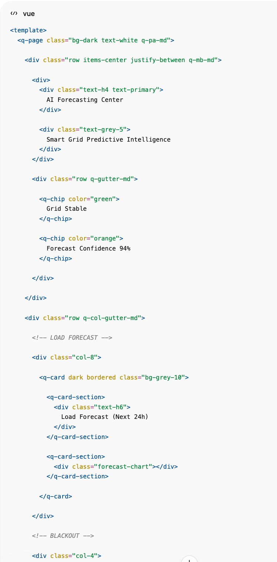  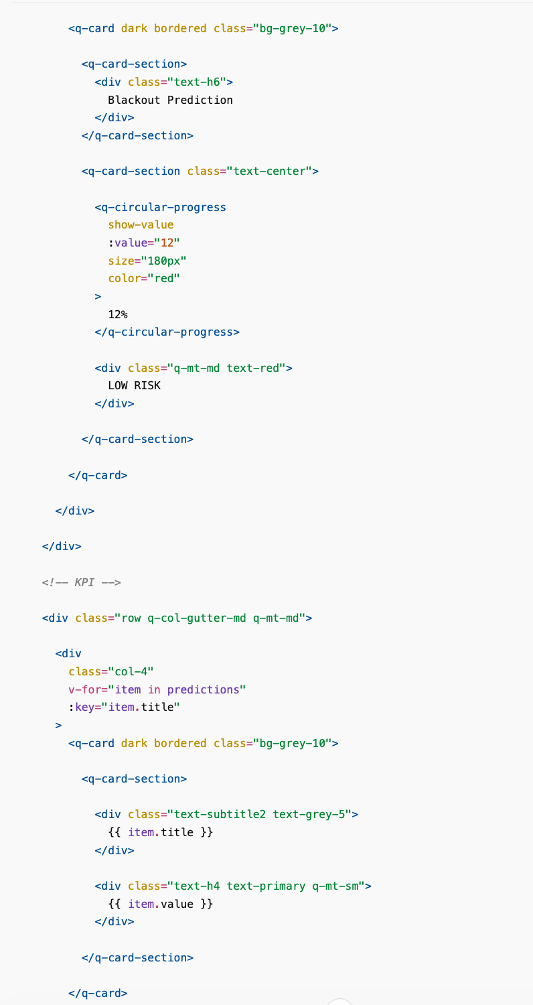  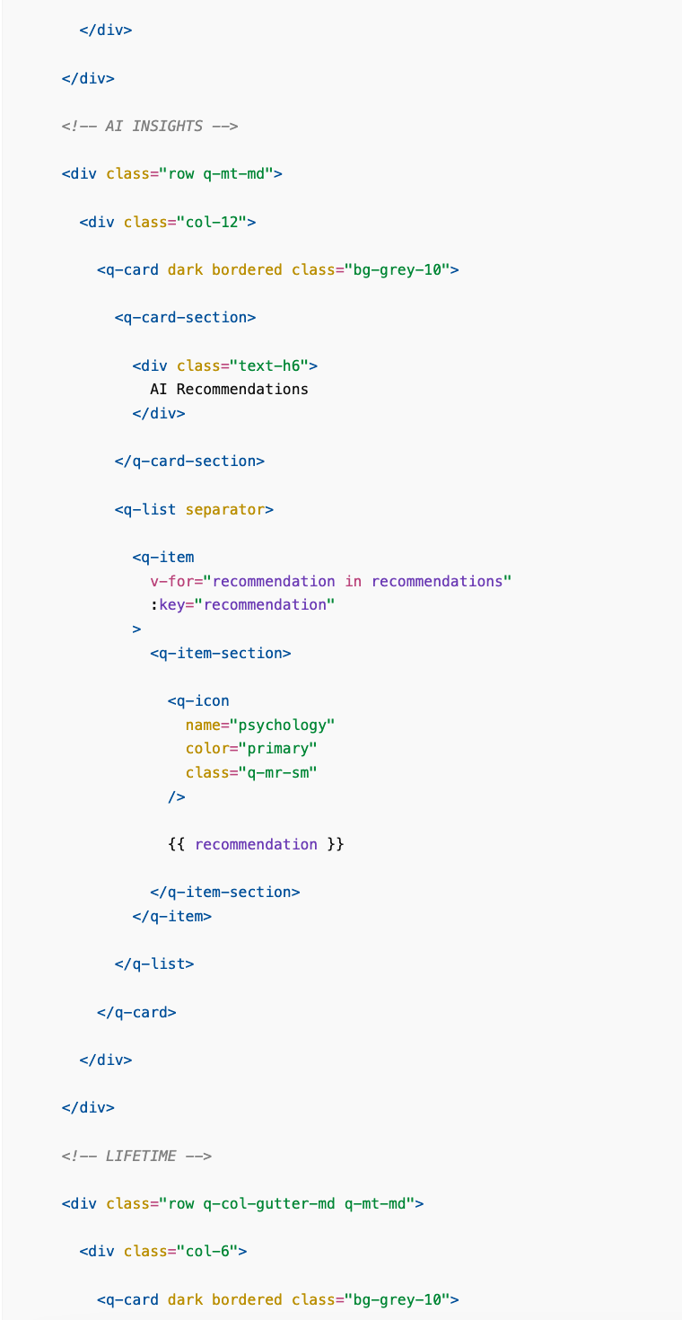  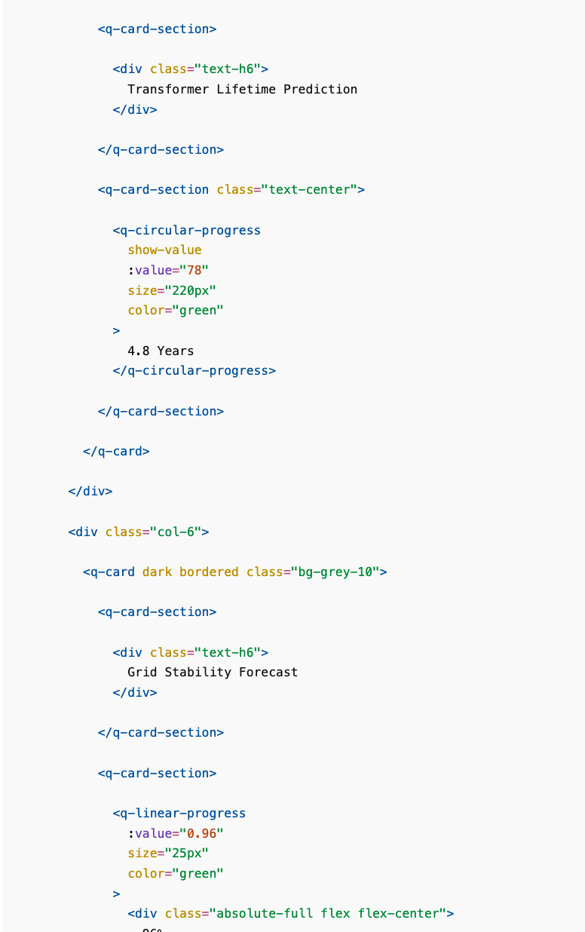  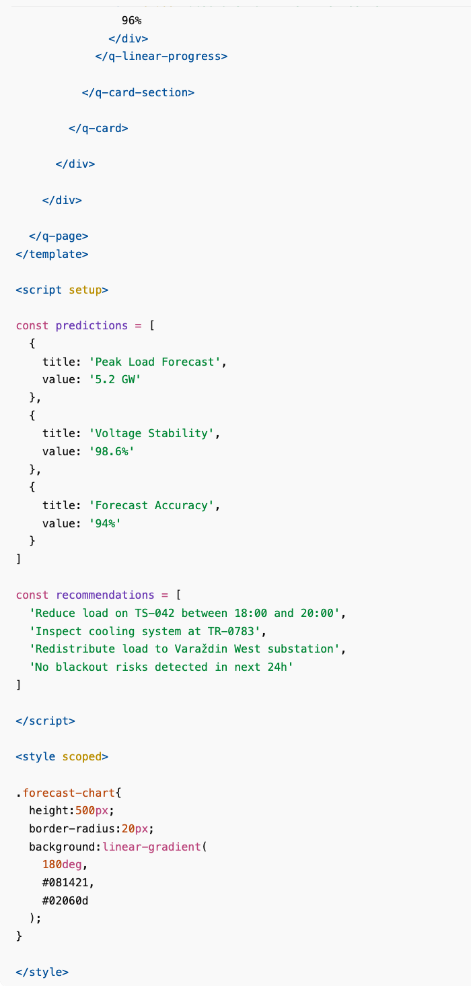

ECharts integracija za Load Forecast
Preporuka:
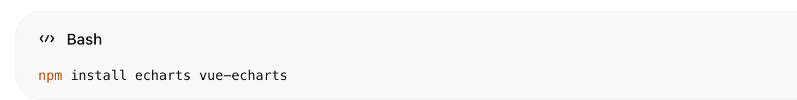
npm install echarts vue-echarts
Grafovi:
- Load Prediction (24h)
- Load Prediction (7 dana)
- Blackout Probability Trend
- Transformer Aging Curve
- Grid Stability Forecast
- Renewable Production Forecast

Dodatni AI widgeti
Za utility-grade verziju dodao bih još:

Top Risk Assets
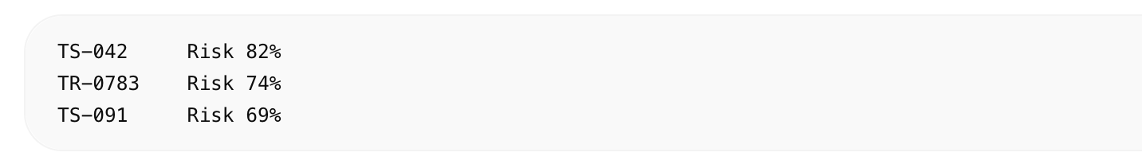
TS-042 Risk 82%
TR-0783 Risk 74%
TS-091 Risk 69%

AI Model Status
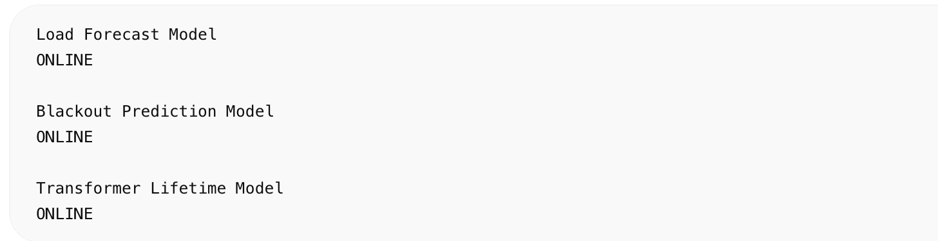
Load Forecast Model
ONLINE
Blackout Prediction Model
ONLINE
Transformer Lifetime Model
ONLINE

Weather Impact
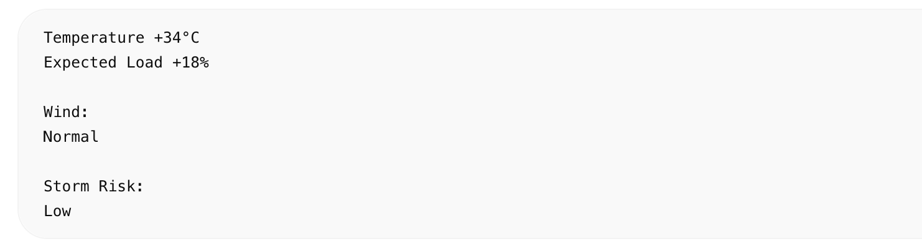
Temperature +34°C
Expected Load +18%
Wind:
Normal
Storm Risk:
Low

Forecast Confidence
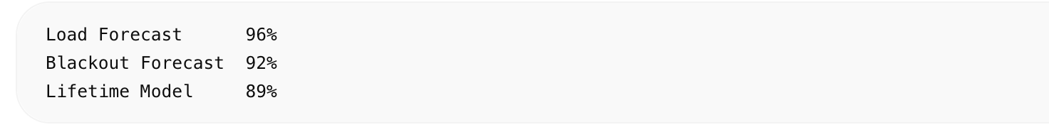
Load Forecast 96%
Blackout Forecast 92%
Lifetime Model 89%
Time dobivaš enterprise AI Forecasting ekran koji se vizualno uklapa uz Dashboard, Grid Map, Transformers, Analytics, Maintenance, Digital Twin i Alarm Center koje smo već definirali za CrateDB Smart Grid Digital Twin platformu.

